Econ Unit 2: Personal Finances Worksheets
SSEPF1: Incentives **Class Copy
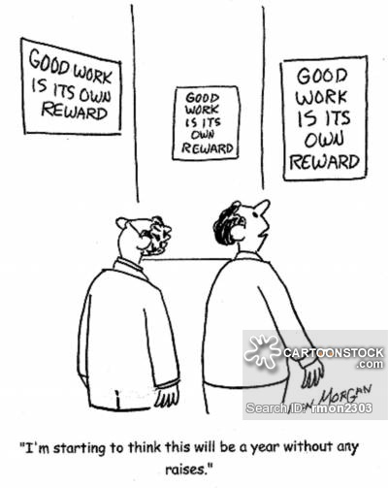
- Why do human beings generally decide to work in life?
- What is the difference between a positive incentive and negative incentive?
- Based on this cartoon, do the workers have any incentive to work harder for their company? Explain in 2-3 sentences.
- How would you react to your supervisor if you worked hard for the company but did not receive a bonus or pay raise?

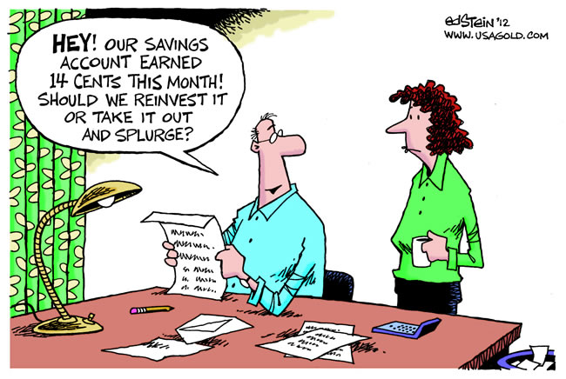
- How much of a return did the couple get from the bank by leaving their money in a savings account?
- Is there an incentive to leave all your money in a savings account when interest rates are low? Explain.
- After examining the cartoon, what investment advice would you give this couple? Should they keep all of their money in a savings account, or should they invest their money in other places? Use the Personal Finance study guide or textbook to explore other investment options.

SSPF1b, c and SSPF2c- Risk vs. Return, Investment Planning
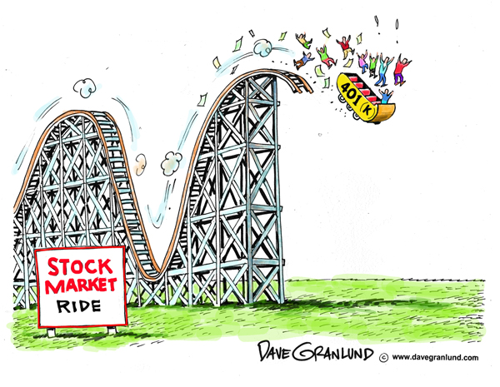
- What are stocks and bonds? What are mutual funds?
- What is the message of the artist when he compares the stock market to a roller coaster?
- What is happening to people’s 401K retirement funds in the cartoon?
- Why is the stock market a “high risk, high reward” investment?
- What might be good economic advice when it comes to investing in the stock market?

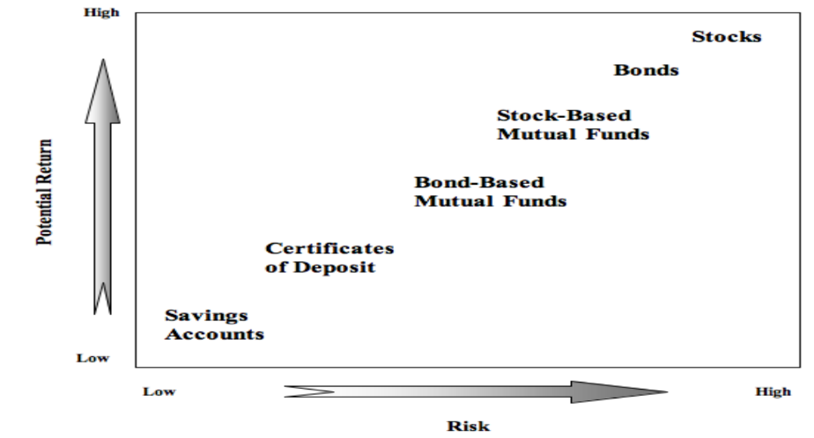

- Which investment has the potential for a big return but a high risk of losing your investment?
- Which stock/bond investment has less risk than just stocks or bonds? Why?
- What is the difference between a savings account and certificates of deposit with regards to interest earned from the bank?
- Based on the diagram below, what do investors need to consider when making investment decisions? Provide an example for each need and goal.
- Unless you have a crystal ball or a time machine, there is no way to predict what will happen to the economy in the long term. What is the best way you can prepare for any future event that impacts your wallet?

SSPF4- Credit, Interest Rates
There are several factors that institutions look into when a consumer applies for credit: your repayment history, your credit score, and your debt-to-income ratio. So how can you tell if your financial stats are desirable?
To gauge your credit worthiness, banks will examine your credit report, which includes information on all your credit accounts, payment history, credit inquiries, and whether or not you’ve ever declared bankruptcy or had a lien placed against you. On the report, any late or missed payments will be noted and remain on it for up to seven years—negatively impacting whether or not you get a loan or a credit-card. That’s why it’s so important to pay your bills on time.
Your credit score is a three-digit number that is the one of the most basic ways for lenders to determine if you’re financially responsible. A personal credit score is calculated by numerous pieces of information from your credit report—including your payment history, the amount you owe (taking into consideration your credit utilization, which is how much credit you’re using compared to your limit), the length of time you’ve had various credit accounts open, the opening of any new credit accounts or credit inquiries made, and the types of credit used (such as credit cards, mortgages, installment loans). If you have a high score—between 740 and 850—you’ll qualify for the best rates from lenders. Provided that you make payments on time, pay off outstanding debt, keep your credit-card balances low, and don’t open up new lines of credit, with time, your score will rise.
Your Debt-to-Income Ratio is just about as important as your credit score when a lender examines your credit worthiness. To calculate it for yourself, simply take your total monthly debt obligations (including payments made toward your mortgage, car loan, or credit-card, for example) and divide that amount by your monthly income. The lower the number, the better. Ideally, it should never exceed 33. In other words, the amount you pay toward your debt should not exceed 33% of your income. If it does, you’ve probably over-extended yourself—and banks are going to view you at a greater risk to default on a loan or line of credit. So work to pay down your debts as quickly as possible.
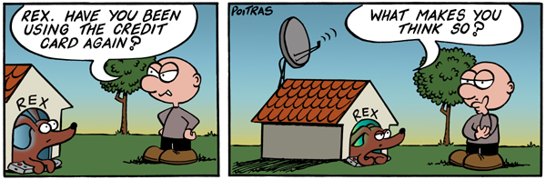
- What is the definition of credit?
- What do lenders charge to make a profit from you borrowing their money?
- What do financial institutions look at to determine your credit worthiness?
- What is included in your credit report?
- What impacts your credit score?
- What is an ideal credit score to have? Why does a high credit score matter?
- What can you do to keep your credit score higher?
- What is meant by debt-to-income ratio?
- At what point will banks most likely refuse to lend you money with regard to debt-to-income ratio?
- After looking at the cartoon, why do a lot of people use credit cards? Think about our discussions of wants vs. needs, and standard of living.

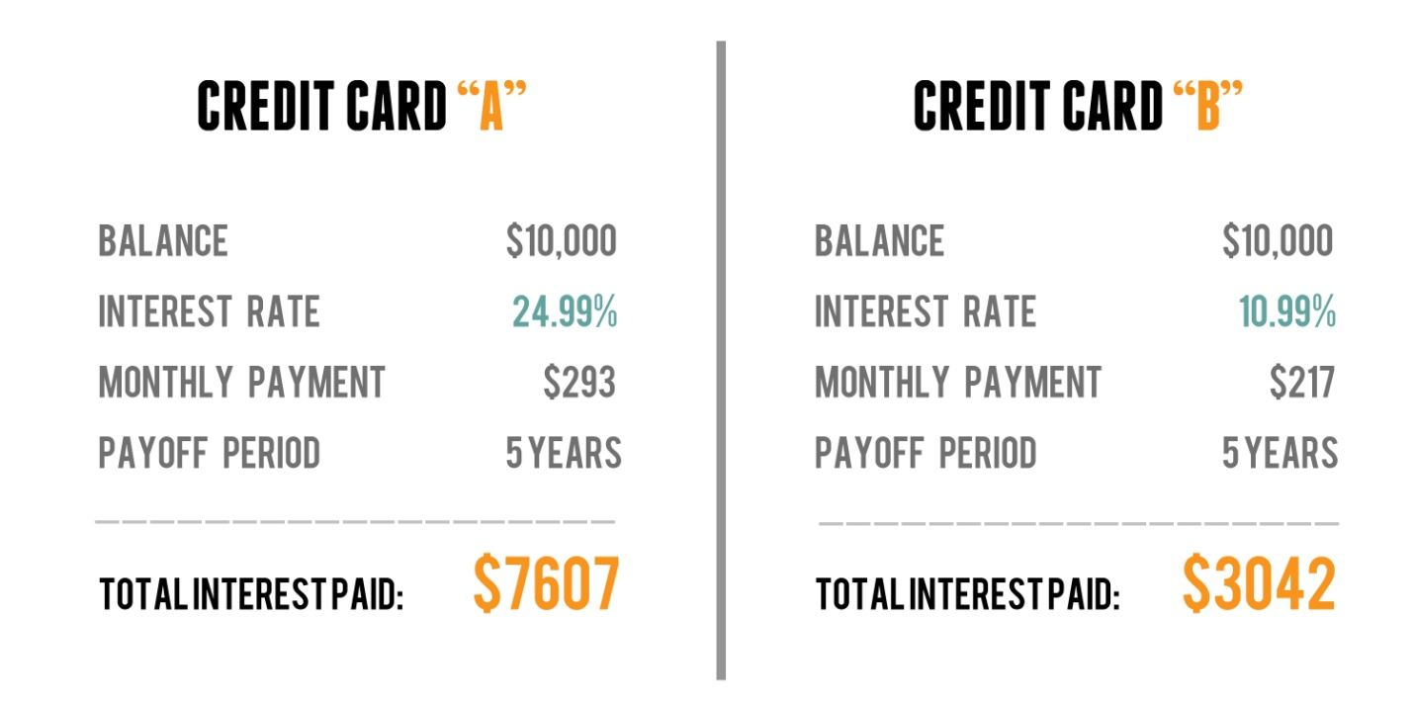
- After comparing the two credit cards, which card is more desirable to obtain?
- Why would someone might be declined for credit card B and only have the option of obtaining credit card A?
- What is the best strategy to use with credit cards to avoid paying a lot of interest?
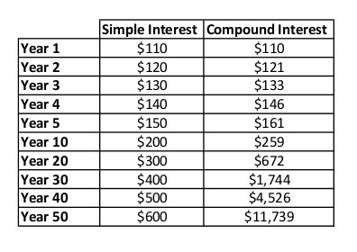
- What is the definition of simple interest? What is the definition of compound interest?
- After looking at the table, which type of interest is more profitable for lenders?

SSPF3: Taxes
Cartoon: (Left to right) Truman, F.D. Roosevelt, Eisenhower, Johnson, Nixon, Reagan, Clinton, G.W. Bush, Obama
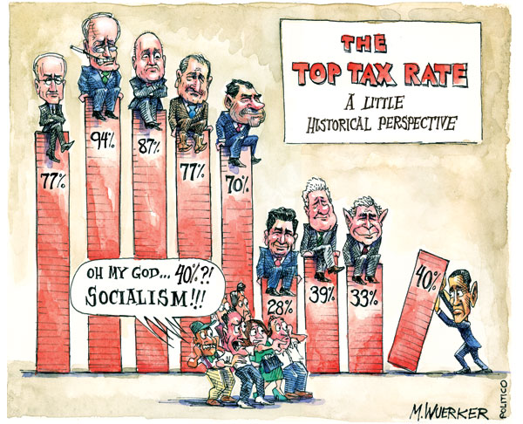
1) What are some of the public goods and services that we pay taxes for?
2) What was the top income tax rate for the wealthiest Americans during President Roosevelt’s tenure during the 1930’s and 40’s? What was President Nixon’s top income tax rate during the early 1970’s?
3) Who had the lowest tax rate for top income earners out of the presidents depicted in the cartoon?
4) What message is the cartoon artist trying to convey? Do you agree or disagree with their perspective? Explain.
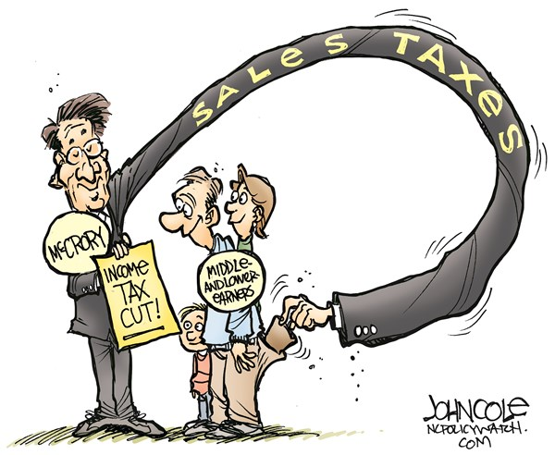
5) Define the different type of taxes and provide an example for each.
6) What type of tax is the sales tax?
7) What type of tax is the American income tax?
8) Why might the sales tax hurt middle and lower income families more than their income tax rate?
9) If you were elected president, what would your tax proposal be to Congress? Explain in 3-4 sentences.

SSPF5: Insurance
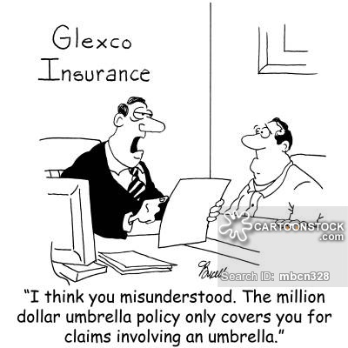
1) What is insurance? What are the different types of insurance?
2) What is the payment that you make to insurance companies for their services?
3) What is the insurance agent telling the customer in the cartoon? What do you think the artist’s opinion is about insurance companies?
4) Why do insurance companies deny insurance claims?
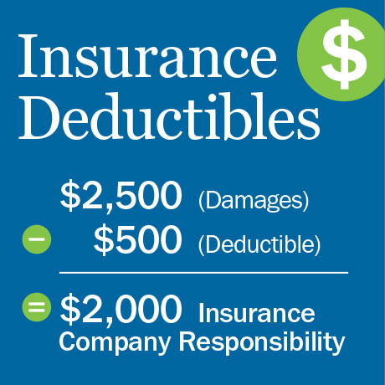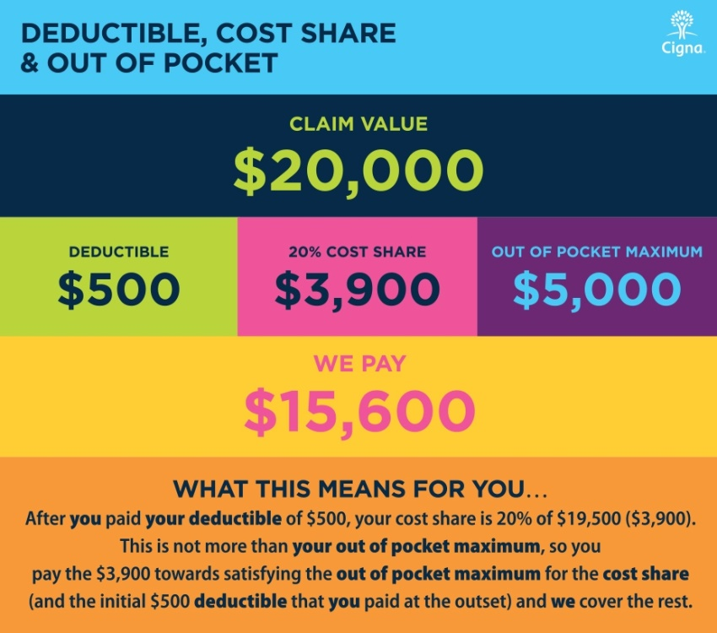
5) After looking at the car insurance diagram on the left, how would you define deductible?
6) The example of a Cigna health insurance plan on the right shows the breakdown of a $20,000 medical bill. How much money does the patient have to pay out of pocket?
7) Why is it illegal in the U.S. to drive without some form of car insurance?
8) The Patient Protection and Affordable Care Act of 2010 penalizes people who do not have health insurance with extra taxes. Why is it problematic when people who don’t have health insurance get sick? Should the government force people to have health insurance, or do you think people should have a choice? Explain your thoughts.

