Unit 4 Macroeconomics Monetary Policy Activity
SSEMA1 The student will illustrate the means by which economic activity is measured.
- Explain that overall levels of income, employment, and prices are determined by the spending and production decisions of households, businesses, government, and net exports.
- Define Gross Domestic Product (GDP), economic growth, unemployment, Consumer Price Index (CPI), inflation, stagflation, and aggregate supply and aggregate demand.
- Explain how economic growth, inflation, and unemployment are calculated.
- Identify structural, cyclical, and frictional unemployment.
- Define the stages of the business cycle; include peak, contraction, trough, recovery, expansion as well as recession and depression
- Describe the difference between the national debt and government deficits.

SSEMA2 The student will explain the role and functions of the Federal Reserve System.
- Describe the organization of the Federal Reserve System
- Define monetary policy
- Describe how the Federal Reserve uses the tools of monetary policy to promote price stability, full employment, and economic growth

EQ: How does the Federal Reserve use the three tools of monetary policy to influence the economy?

Materials Needed
- Fake Money for Fed, Banks, Households, and Businesses
- Treasury Bonds (U.S. Securities) x 5 and $100,000 bills x 5
- Fed Signs: Expansionary & Contractionary Policy, Open Market Operations, Reserve Requirement, Discount Rate
- Economists Signs: Full Employment, Recession, Economic Growth (Inflationary Gap)
- Interest Rates: 3%, 5%, 10%
- Signs: Federal Reserve Sign (FOMC), Commercial Banks, Firms, Households, Economists, POTUS

Monetary Activity
The teacher will select the following groups to participate in several mock macroeconomic scenarios that incorporate knowledge and interpretation of how aggregate demand and aggregate supply impact the business cycle and influencing recessions, unemployment rates, price levels (inflation), full employment, and economic growth. First the teacher will provide an economic scenario to the team of macroeconomists to decipher and plot of 3 specific economic graphs: PPC, Business Cycle, and AD/AS. Students will then determine what the Federal Reserve’s proper response to each economic situation should be when applying the appropriate monetary policy (contractionary or expansionary). Once the FOMC has made the decision to either expand or contract the nation’s money supply, the Chair of the Fed will select which monetary tool (Open Market Operations, Reserve Requirement, or Discount Rate) should be implemented. The Fed Chair will then rely the information or buy/sell U.S. Securities/Treasury Bonds to commercial banks to increase or decrease the money supply. After the commercial banks money supply has been affected by the chosen monetary policy, the banks will then show the impact on the interest rates to the households (Consumption) and the firms/businesses (Investment) to decide whether they should increase loans or purchase investments with a high rate of return. After the process has been completed, the macroeconomists will show the overall impact on the economy using 3 specific graphs: PPC, Business Cycle, and AD/AS.
U.S. Securities

TREASURY BOND
$100,000

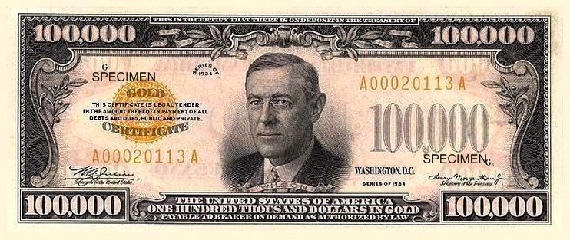

Federal Reserve

Federal Open Market Committee (FOMC)

Expansionary Monetary Policy

- Open Market Operations
- “Easy-Money”
- Buy Bonds (“Buy Big”)
- Reserve Requirement
- 10% or Lower
- Discount Rate
- decrease (1.00 Now)
Contractionary Monetary Policy

- Open Market Operations
- “Tight-Money”
- Sell Bonds (“sell small”)
- Reserve Requirement
- Raise from 10%
- Discount Rate
- Increase (1.00 Now)

Commercial
Banks

Credit
Union

Interest Rates

3%

Interest Rates

5%

Interest Rates

10%

Certificate of Deposits
(CD’s)

Households
(Individuals)
Consumption
AD = C’ + I + G + X_{n}
Firms
(Businesses)
Investment
AD = C + I’ + G + X_{n}
Macroeconomists
- Production Possibilities Curve (PPC)
- Business Cycle
- Aggregate Demand and Aggregate Supply Graph
Macroeconomists
- Phillips Curve
- Money Market Curve
- Loanable Funds Curve

Unemployment Rates

NRU = 5%

Increase or Decrease

Price Level

Normal Inflation % = 1-3%

Increase or Decrease

Real GDP
(Output)

GDP Growth Rate = 3-4%

Expansion or Contraction

POTUS

Senate

House of Representatives

Fed
Chair

Federal Reserve

(7) Board of Governors
District 2
(New York)

Fed President
District 6
(Atlanta)

Fed President
District 12
(San Francisco)

Fed President
District 1
(Boston)

Fed President
District 7
(Chicago)

Fed President
News
Reporter

2 Consecutive Quarters (6 months) of negative real GDP

Recessionary
Gap

Unemployment Rate is at the NRU 5%

Economy is experiencing Cyclical Unemployment

Economic Growth has increased in the short-run past Full Employment

Inflationary
Gap

(Aggregate Demand increased)

What is the impact on the macroeconomy (GDP) if the U.S. has a trade deficit?

AD = C + I + G + (X-M)’

What is the impact on the economy (GDP) if business investment in capital goods increases by 25%?

AD = C + I’ + G + (X-M)

What is the impact on the economy (GDP) if the government increases spending and decreases taxes?

AD = C + I + G’ + (X-M)

What is the impact on the economy (GDP) if the private sector consumption decreases by 50% due to poor consumer confidence?

AD = C’ + I + G + (X-M)
Using discretionary Fiscal Policy (gov’t spending), how can Congress close a $100 billion recessionary gap if the MPC is .8?

AD = C + I + G’ = X_{n}

Using discretionary Fiscal Policy (gov’t spending), how can Congress close a $20 billion recessionary gap if the MPC is .5?

AD = C + I + G’ = X_{n}

